Write Verilog and Testbench Code to Implement a 4:1 Multiplexer
Aim
To design, implement, and simulate a 4:1 Multiplexer (MUX) using Verilog HDL and verify its operation using a testbench in Quartus Prime and QuestaSim.
Objective
After completing this experiment, students will be able to:
- Understand the working principle of a 4:1 Multiplexer.
- Write Verilog HDL code for a combinational logic circuit.
- Develop a testbench for functional verification.
- Simulate the design using QuestaSim.
- Verify the truth table using simulation waveform.
Theory:
A Multiplexer (MUX) is a combinational logic circuit that selects one input from multiple input lines and forwards the selected input to a single output line. Because it selects one input out of many, it is also known as a Data Selector. Multiplexers are widely used in digital systems for efficient data routing, communication, and resource sharing.
A 4:1 Multiplexer has four data inputs (I0, I1, I2, and I3), two select lines (S1 and S0), and one output (Y). The two select lines determine which one of the four input signals is connected to the output. Since there are four input lines, two select lines are sufficient because $2^{2}=4$. Depending on the binary value of the select inputs, only one of the four data inputs appears at the output, while the remaining inputs are ignored.
The operation of a 4:1 Multiplexer is straightforward. When the select lines are S1S0 = 00, the output is equal to I0. When S1S0 = 01, the output becomes I1. Similarly, for S1S0 = 10, the output is I2, and for S1S0 = 11, the output is I3. Thus, the output changes according to the binary combination of the select inputs, allowing controlled selection of any one of the four input signals.
The Boolean expression of a 4:1 Multiplexer is given by:
$$Y=\overset{‾}{S_{1}} \overset{‾}{S_{0}} I_{0}+\overset{‾}{S_{1}}S_{0}I_{1}+S_{1}\overset{‾}{S_{0}}I_{2}+S_{1}S_{0}I_{3}$$
This expression shows that only one product term becomes active for each combination of the select lines, ensuring that only the selected input is transferred to the output.
They are extensively used in microprocessors, digital communication systems, memory address selection, data routing, Arithmetic Logic Units (ALUs), control units, and FPGA/ASIC designs. Multiplexers help in minimizing the number of wires and switching circuits, thereby reducing the overall cost and improving system efficiency.
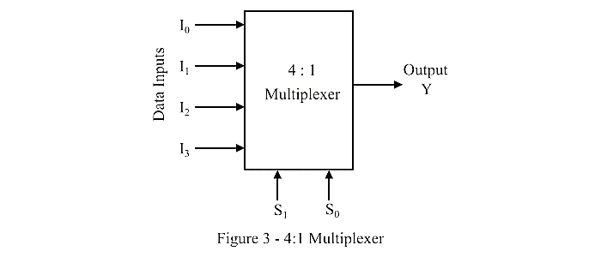
Block Diagram

Truth Table
S1 | S0 | Output (Y)
0 | 0 | I0
0 | 1 | I1
1 | 0 | I2
1 | 1 | I3
Algorithm
- Start.
- Declare four data inputs.
- Declare two select inputs.
- Declare one output.
- Use a case statement to select one input.
- Write the testbench.
- Apply all combinations of select lines.
- Observe the waveform.
- Verify the truth table.
- Stop.

Verilog Code (Design Module)

module mux4to1 (

input I0,

input I1,

input I2,

input I3,

input S1,

input S0,

output reg Y

);

always @(*) begin

case ({S1, S0})

2'b00: Y = I0;

2'b01: Y = I1;

2'b10: Y = I2;

2'b11: Y = I3;

default: Y = 1'b0;

endcase

end

endmodule
Testbench
`timescale 1ns/1ps

module mux4to1_tb;

reg I0;
reg I1;
reg I2;
reg I3;
reg S1;
reg S0;

wire Y;

mux4to1 uut(
.I0(I0),
.I1(I1),
.I2(I2),
.I3(I3),
.S1(S1),
.S0(S0),
.Y(Y)
);

initial
begin

I0=0; I1=1; I2=0; I3=1;

S1=0; S0=0;
#10;

S1=0; S0=1;
#10;

S1=1; S0=0;
#10;

S1=1; S0=1;
#10;

$stop;

end

endmodule

Simulation Procedure (Quartus Prime & QuestaSim)
- Open Intel Quartus Prime.
- Create a new project.
- Create a Verilog file named mux4to1.v.
- Enter the design code.
- Save the file.
- Create another Verilog file named mux4to1_tb.v.
- Enter the testbench code.
- Set mux4to1 as the top-level entity.
- Compile the design.
- Launch QuestaSim using Tools → Run Simulation Tool → RTL Simulation.
- Add all input and output signals to the waveform window.
- Run the simulation.
- Observe the output waveform.
- Verify the truth table.

Expected Simulation Result
I0 | I1 | I2 | I3 | S1 | S0 | Expected Y
0 | 1 | 0 | 1 | 0 | 0 | 0
0 | 1 | 0 | 1 | 0 | 1 | 1
0 | 1 | 0 | 1 | 1 | 0 | 0
0 | 1 | 0 | 1 | 1 | 1 | 1

Observation
The output Y changes according to the select inputs S1 and S0, selecting one of the four input lines as expected.
Applications
- Data routing
- Communication systems
- Processor design
- Memory selection
- FPGA and ASIC design
- Digital switching circuits

Advantages
- Reduces hardware complexity.
- High-speed data selection.
- Easy FPGA implementation.
- Efficient digital design.
- Low power consumption

Viva Questions
- What is a multiplexer?
- Why is a multiplexer called a data selector?
- How many select lines are required for a 4:1 multiplexer?
- How many inputs and outputs does a 4:1 MUX have?
- What is the Boolean expression of a 4:1 MUX?
- What is the difference between a multiplexer and a decoder?
- Why is a testbench required?
- What is the purpose of the case statement in Verilog?
- What is the function of always @(*)?
- What is the difference between RTL simulation and gate-level simulation?

